

**LA GRANDEE INTERNATIONAL COLLEGE**

**Simalchaur, Pokhara, Nepal**

Assignment I

**Submitted to**

Mr. Ashwin Poudel

La Grandee International College

Bachelor of Computer Application (BCA) Program

**Submitted by**

|  |  |  |  |
| --- | --- | --- | --- |
| **Name:** | **Course** | **Semester** | **P.U. Registration Number** |
| Namrata Bastola | BCA | 6th | 2022-1-53-0129 |

**Date: 4th May 2025**

1. **Question**

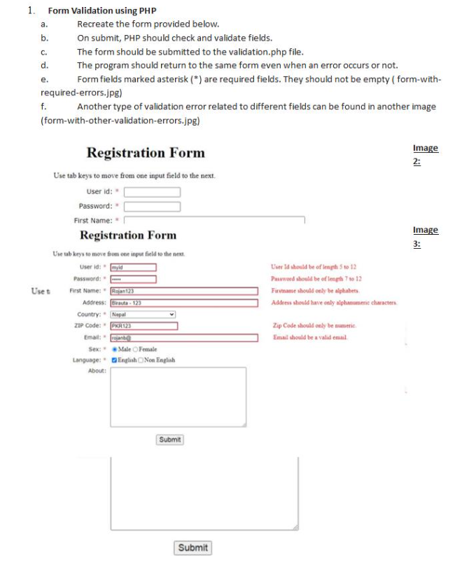

1. **Introduction**

This project contains a basic registration form through HTML and PHP. The concept is to stop users from entering invalid data until the form has been approved and saved. Every input is checked by the backend script and indicated as errors in case of error. In case of correctness in all fillings, data is saved within the database in a secure manner.

**3.form.php**

<!DOCTYPE html>

<html lang="en">

<head>

    <meta charset="UTF-8">

    <title>Assignment1</title>

</head>

<body>

    <h1>Registration Form</h1>

    <p>Use tab keys to move from one input field to the next.</p>

    <form method="POST" action="validation.php">

        <label for="userid">User ID: <span style="color: red;"> * </span></label>

        <input type="text" id="userid" name="userid" required><br><br>

        <label for="password">Password: <span style="color: red;"> * </span></label>

        <input type="password" id="password" name="password" required><br><br>

        <label for="fname">First Name:<span style="color: red;"> * </span></label>

        <input type="text" id="fname" name="fname" required><br><br>

        <label for="address">Address:</label>

        <input type="text" id="address" name="address"><br><br>

        <label for="country">Country: <span style="color: red;"> * </span></label>

        <select id="country" name="country">

            <option value="Nepal">Nepal</option>

            <option value="India">India</option>

            <option value="USA">USA</option>

        </select><br><br>

        <label for="zip">ZIP Code: <span style="color: red;"> * </span></label>

        <input type="text" id="zip" name="zip"><br><br>

        <label for="email">Email: <span style="color: red;"> * </span></label>

        <input type="email" id="email" name="email"><br><br>

        <label>Sex: <span style="color: red;"> * </span></label>

        <input type="radio" name="gender" value="Male" id="male"><label for="male">Male</label>

        <input type="radio" name="gender" value="Female" id="female"><label for="female">Female</label><br><br>

        <label>Language: <span style="color: red;"> * </span></label>

        <input type="checkbox" name="language[]" value="English">English

        <input type="checkbox" name="language[]" value="Non English">Non English<br><br>

        <label for="about">About:</label><br>

        <textarea name="about" id="about" rows="4" cols="40"></textarea><br><br>

        <button type="submit">Submit</button>

    </form>

</body>

</html>

**4.validation.php**

<?php

$errors = [];

if ($_SERVER["REQUEST_METHOD"] == "POST") {

    // Get form values directly

    $userid = $_POST['userid'];

    $password = $_POST['password'];

    $fname = $_POST['fname'];

    $address = $_POST['address'];

    $country = $_POST['country'];

    $zip = $_POST['zip'];

    $email = $_POST['email'];

    $gender = $_POST['gender'];

    $language = $_POST['language'];

    $about = $_POST['about'];

    // Validations

    if (strlen($userid) < 5 || strlen($userid) > 12) {

        $errors[] = "User ID should be of length 5 to 12.";

    }

    if (strlen($password) < 7 || strlen($password) > 12) {

        $errors[] = "Password should be of length 7 to 12.";

    }

    if (!ctype_alpha($fname)) {

        $errors[] = "Firstname should only be alphabets.";

    }

    if (!empty($address) && !ctype_alnum(str_replace(' ', '', $address))) {

        $errors[] = "Address should have only alphanumeric characters.";

    }

    if (!ctype_digit($zip)) {

        $errors[] = "Zip Code should only be numeric.";

    }

    if (!filter_var($email, FILTER_VALIDATE_EMAIL)) {

        $errors[] = "Email should be a valid email.";

    }

    if (empty($gender)) {

        $errors[] = "Please select your sex.";

    }

    if (empty($language)) {

        $errors[] = "Please select at least one language.";

    }

    if (empty($errors)) {

        echo "<h2 style='color: green;'>✔️ All fields are valid. Form submitted successfully!</h2>";

    } else {

        include 'form.php';

        echo "<h2 style='color: red;'>Please correct the following errors:</h2><ul style='color:red;'>";

        foreach ($errors as $error) {

            echo "<li>$error</li>";

        }

        echo "</ul>";

    }

} else {

    header("Location: form.php");

    exit;

}

?>

**5.Output**

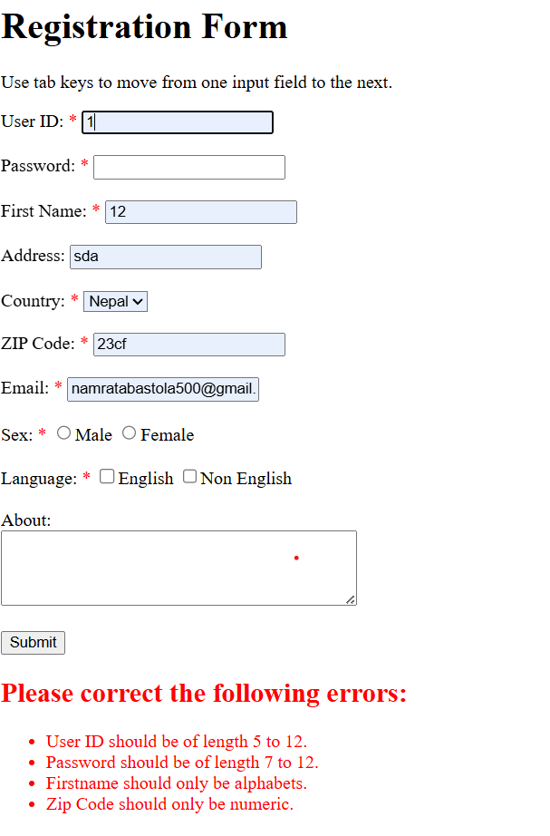

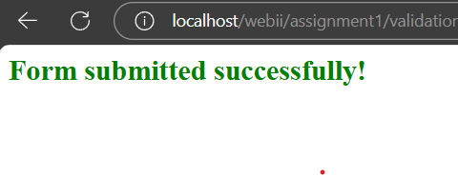

**6. Conclusion**

This project successfully performs a simple form of registration with input validation using PHP. The project rightly requires fields and shows proper error messages when there are incorrect inputs. The system completes the assignment requirements without using the use of a database.